**Assignment 3:**

Comparison of Motors in Embedded System

**Embedded Systems Design**

**MCTE 4342**

**SECTION 1**

**SEM 2 SESSION 2023/2024**

**NAME:** WAN MUHAMMAD RAFIQ BIN WAN MOHD RUSHDAN

**NO MATRIC:** 2011341

**LECTURER:** ASSOC. PROF. DR. ZULKIFLI BIN ZAINAL ABIDIN

# DC Motors

1. Description:   
   The DC motors is one of the motors that are commonly found in the market with different types of variation and specification. A DC motor's speed can be controlled over a wide range, using either a variable supply voltage or by changing the strength of current in its field windings. Small DC motors are used in tools, toys, and appliances.
2. Types of DC Motors:

* Permanent Magnet DC Motor (PMDC Motor)
* Separately Excited DC Motor
* Self-Excited DC Motor
* Shunt Wound DC Motor
* Series Wound DC Motor
* Compound Wound DC Motor
* Short shunt DC Motor
* Long shunt DC Motor
* Differential Compound DC Motor
* Brushless DC Motor
* Switch Reluctance Motor

However, in small applications mainly the geared DC motors and brushless DC motor

* Example Geared DC Motor:

Worm Gear Motor, Planetary Gear DC Motor, Micro-metal gear motor, gear reduction dc motor, cycloidal drive motor,

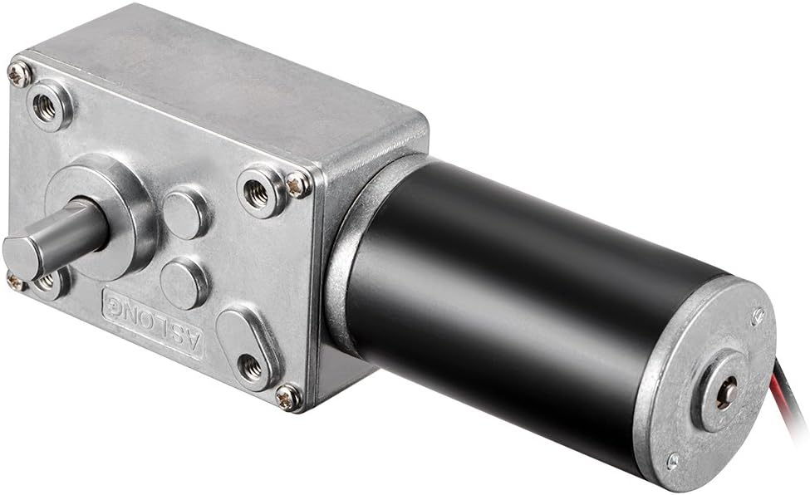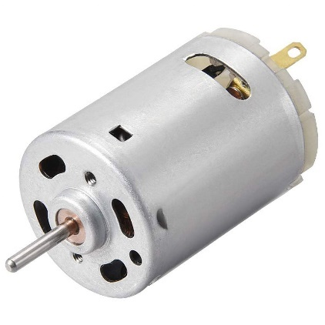

Figure ‎0‑1: Worm Gear Motor

Figure ‎0‑2: Common DC motor

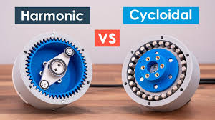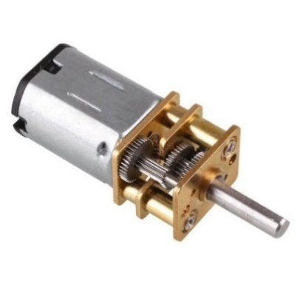

Figure ‎0‑3: Harmonic and Cycloidal Drive

Figure ‎0‑4: Micro Metal Gear Motor

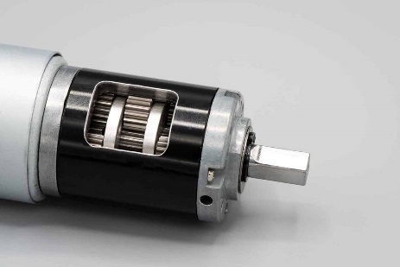

Figure ‎0‑5: Planetary gear dc motor

1. Advantages and Disadvantages

|  |  |
| --- | --- |
| **Advantages** | **Disadvantages** |
| Simple control of speed | Require frequent maintenance |
| High starting torque | Higher initial cost compared to AC motors |
| Smooth and wide range of speed control | Brushes and commutator wear out over time |
| Excellent response to control signals | Lower efficiency due to friction and heat |
| Better for applications requiring precise speed control | Limited speed due to commutator limitations |
| Can operate in low-voltage applications | Bulky and heavier than equivalent AC motors |

# Servo Motors

1. Description:

DC motor that are built to position mechanical elements at a given position within a given time and with precision. A servo motor is an electromechanical device that produces torque and velocity based on the supplied current and voltage. A servo motor works as part of a closed loop system providing torque and velocity as commanded from a servo controller utilizing a feedback device to close the loop. The feedback device supplies information such as current, velocity, or position to the servo controller, which adjusts the motor action depending on the commanded parameters.

1. Type of Servo Motor:

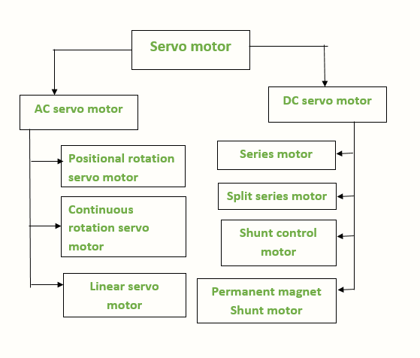

The main focus of this report servo dc motor. The dc servo motors are built with DC source that are separated in the field of armature winding. It can be controlled by managing the field current or the armature current.

Mostly Common used in small applications: 180 degrees & 270 degrees servo, continuous servo

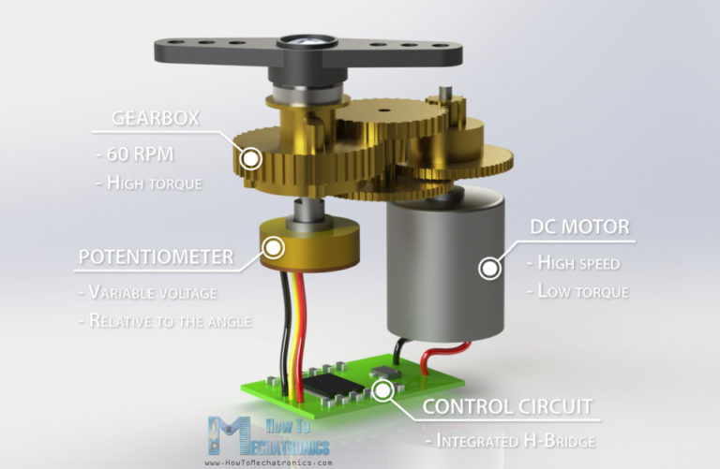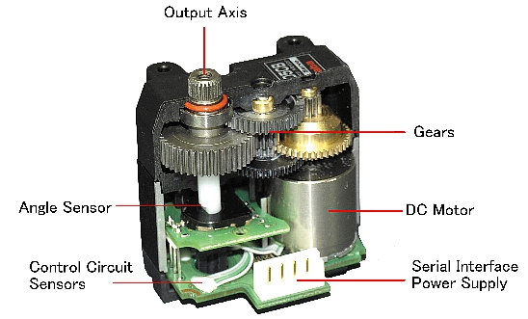

Figure ‎0‑1: Continous Servo

Figure ‎0‑2Internal of Positional Servo

1. Advantage and disadvantage of servo motor.

|  |  |
| --- | --- |
| **Advantages** | **Disadvantages** |
| High precision and accuracy | Higher cost compared to stepper motors |
| Excellent torque at low speeds | Complex control systems required |
| High efficiency and performance | More sensitive to changes in load conditions |
| Fast response and quick acceleration | Can be affected by electromagnetic interference |
| Suitable for high-speed operations | Require regular tuning and maintenance |
| Smooth rotation over a wide range of speeds | Limited by maximum speed constraints |
| Can hold position without oscillation | Require feedback systems (encoders) |

# Dynamixel Motor

1. Description:

* The DYNAMIXEL is a smart actuator system developed to be the exclusive connecting joints on a robot or mechanical structure.
* DYNAMIXELs are designed to be modular, and daisy chained on any robot or mechanical design for powerful and flexible robotic movements.

.

1. Type of Dynamixel Motor

* DYNAMIXEL DRIVE (DYD)
* DYNAMIXEL-Y
* DYNAMIXEL-P
* DYNAMIXEL-X

Figure ‎0‑1: Stall torque versus speed of Dynamixel Lineup

Figure ‎0‑2: Daisy Chain Link of Dynamixel

Figure ‎0‑3: Dynamixel Linup

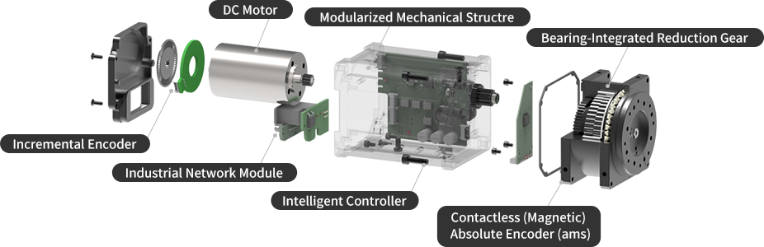

Figure ‎0‑4: Example of Internal Structure of Dynamixel

1. Advantage and Disadvantage

|  |  |
| --- | --- |
| **Advantages** | **Disadvantages** |
| High precision and reliability | Higher cost compared to standard servo motors |
| Integrated feedback and control systems | Can be complex to program and configure |
| Daisy-chain capability for simpler wiring and control | Requires proprietary communication protocols |
| Wide range of models for different torque and speed needs | Higher power consumption |
| Robust and durable, suitable for heavy-duty applications | May require specialized power supplies |
| Easy integration with various robotic platforms | Limited compatibility with non-Robotic controllers |
| Support for advanced features like velocity, position, and torque control | Possible overkill for simple applications |

# Stepper Motor

1. Description:

A stepper motor is an electric motor whose main feature is that its shaft rotates by performing steps, that is, by moving by a fixed number of degrees. This feature is obtained thanks to the internal structure of the motor and allows to know the exact angular position of the shaft by simply counting how may steps have been performed, with no need for a sensor.

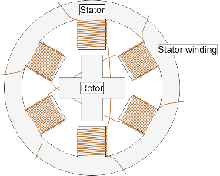 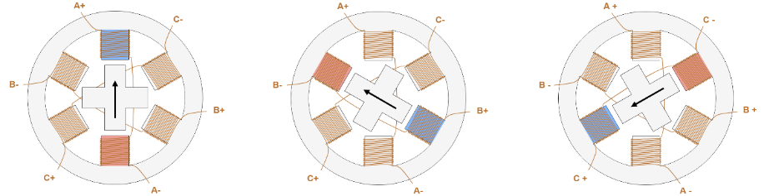

Figure ‎0‑1: Cross Section and step of Stepper Motor

1. Type of Stepper Motor

* Rotor
  + - Permanent magnet rotor
    - Variable reluctance rotor
    - Hybrid rotor
* Stator
  + Two Phase
  + Three Phase
  + Five Phase
* Polar
  + Uni-polar
  + Bi-polar (most common used)

1. Techniques

* Step/Direction – By sending a pulse on the Step pin, the driver changes its output such that the motor will perform a step, the direction of which is determined by the level on the Direction pin.
* Phase/Enable – For each stator winding phase, Phase determines the current direction and triggers Enable if the phase is energized.
* PWM – Directly controls the gate signals of the low-side and high-side FETs.

1. Advantage and Disadvantage

|  |  |
| --- | --- |
| **Advantages** | **Disadvantages** |
| Do not require a sensor for position detection | Can miss a step if the load torque is too high |
| Simple control and lower control effort | No way to know the real position if steps are missed |
| High position accuracy with micro stepping (up to ~0.007°) | More likely to miss steps with micro stepping |
| Good torque at low speeds | Always drain maximum current, even when still |
| Great for holding position | Lower efficiency and potential for overheating |
| Long lifespan | Low torque at high speeds, becoming noisy |
|  | Low power density and low torque-to-inertia ratio |

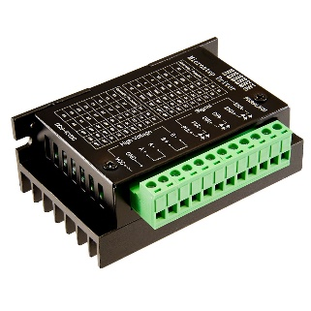 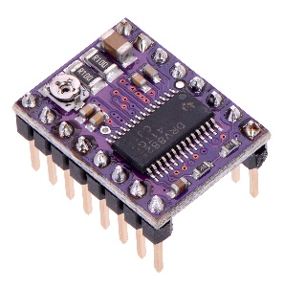 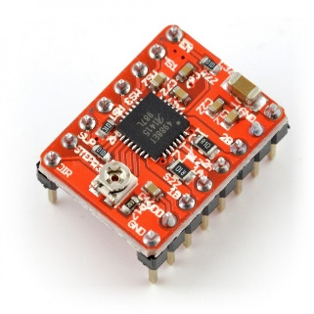 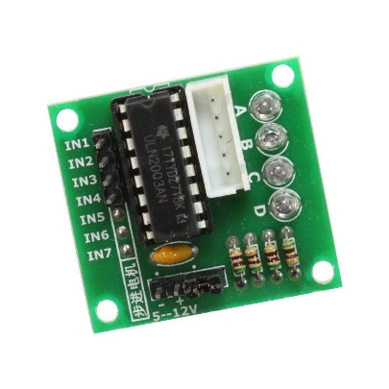

Figure ‎0‑2: Stepper Motor Driver

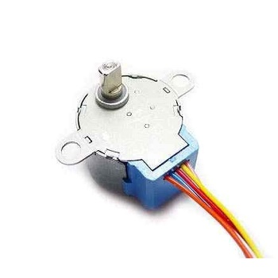

Figure ‎0‑3: Unipolar Stepper Motor

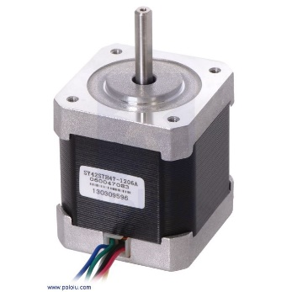

Figure ‎0‑5 Microstep Stepper Motor

Figure ‎0‑4: Bipolar Stepper Motor

# Brushless Motor

1. Description:

* Brushless DC motors (BLDC) feature high efficiency and excellent controllability and are widely used in many applications.
* Fixed brushes supply electric energy to the rotating commutator. As the commutator rotates, it continually flips the direction of the current into the coils, reversing the coil polarities so that the coils maintain rightward rotation. The commutator rotates because it is attached to the rotor on which the coils are mounted.



Figure ‎0‑1: Working mechanism of BLDC.

1. Type of BLDC

-In runner: permanent magnets on the outer section that moves as it turns the output shaft.

-Outrunner: electromagnets inside a fixed outer housing, while permanent magnets are on the internal rotor.

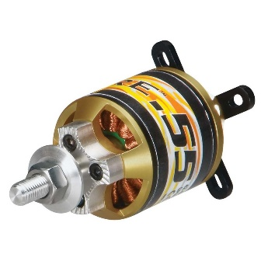

Figure ‎0‑2: Outrunner BLDC

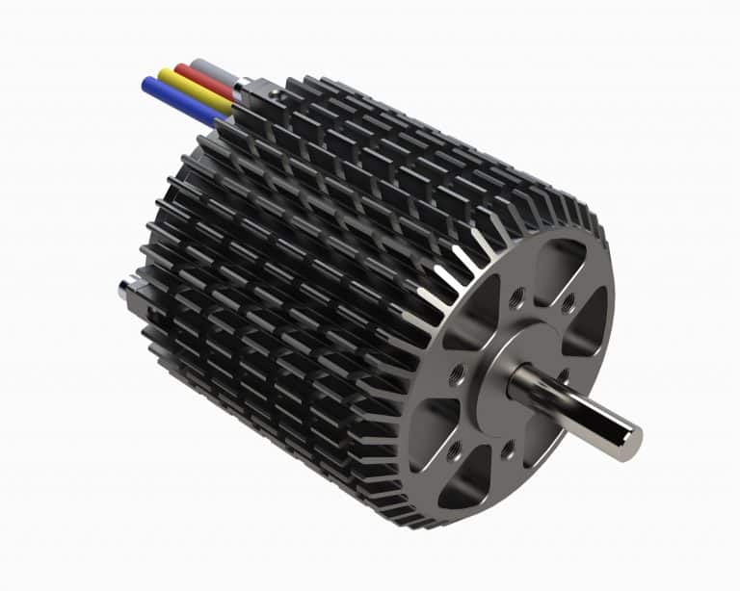

Figure ‎0‑3: Inrunner BLDC

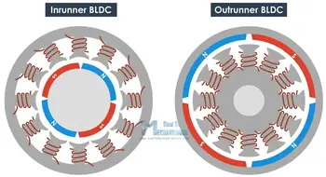

Figure ‎0‑4: Comparison of Outerunner and Inrunner BLDC

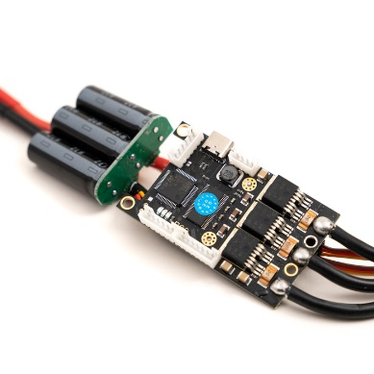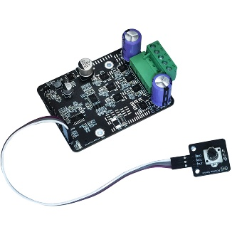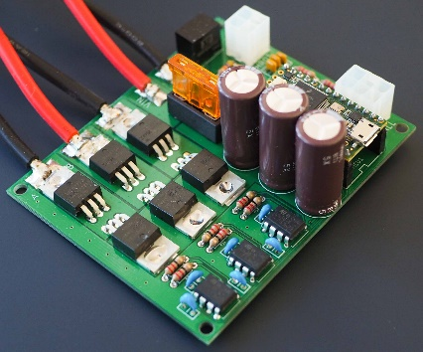

Figure ‎0‑5: Motor driver for BLDC.

1. Advantage and Disadvantage

|  |  |
| --- | --- |
| **Advantages** | **Disadvantages** |
| High efficiency and reliability | Higher initial cost compared to brushed motors |
| Low maintenance due to absence of brushes | Requires a complex controller for operation |
| Long lifespan | Can generate electromagnetic interference (EMI) |
| High power density and compact size | More challenging to repair due to complex electronics |
| Excellent speed-torque characteristics | Initial setup and tuning can be more complicated |
| Smooth operation and low noise | Requires precise control of current and voltage |
| Better heat dissipation, allowing for higher power output | Limited availability of standard parts for repair |

# Linear Actuators Motor

1. Description

* Electric Linear Actuators are a type of actuator that converts energy and signals into a linear motion, in other words a backward or forward motion.
* This linear motion is then used to tilt, lift, push or pull an object where force is required.

1. Types of Linear Actuators

* Mechanical or electromechanical linear actuators
* Hydraulic linear actuators
* Pneumatic linear actuators
* Piezoelectric actuators

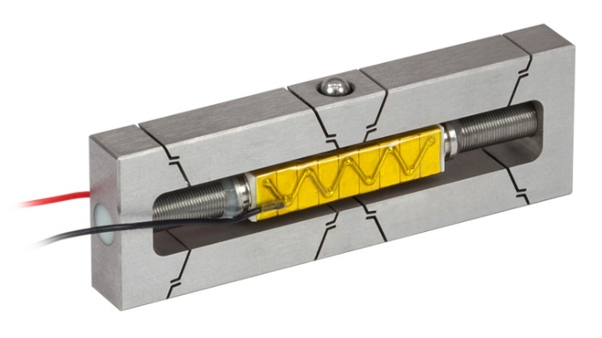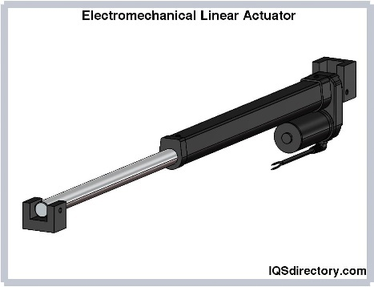

Figure ‎0‑1: Piezoelectric Linear Actuator

Figure ‎0‑2: Electromechanical Linear Actuator

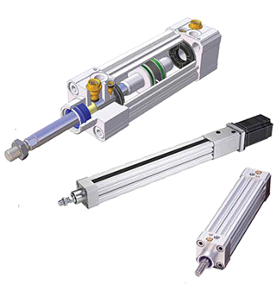 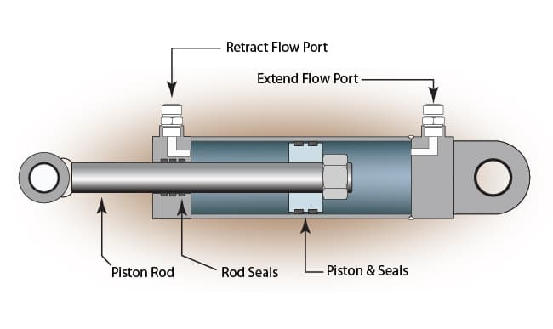

Figure ‎0‑3: Pnuematic Linear Actuator

Figure ‎0‑4: Hydraulic Linear Actuator

1. Advantage and Disadvantage

|  |  |
| --- | --- |
| **Advantages** | **Disadvantages** |
| Precise and repeatable motion | Limited speed compared to rotary actuators |
| Can generate high force with compact size | Can be expensive, especially for high-precision models |
| Simple design and easy to install | Limited stroke length in some models |
| Quiet and smooth operation | Require regular maintenance in some types (e.g., screw actuators) |
| Versatile and can be used in a variety of applications | Potential for backlash in mechanical components |
| Good for applications requiring push/pull actions | Limited duty cycle in some models |
| Can be controlled with high precision using feedback systems | Power consumption can be high for high-force applications |